HEALTHAI: Intelligent Healthcare Assistant using IBM Granite

(Team ID: LTVIP2025TMID30263)



1. INTRODUCTION
   1. Project Overview

HEALTHAI: Intelligent Healthcare Assistant using IBM Granite is a generative AI-powered application designed to provide smart healthcare support to patients through an interactive and intuitive interface. The system leverages IBM's Granite language model to facilitate health-related conversations, predict diseases based on symptoms, suggest possible treatment plans, and display useful health analytics. Developed using Python and Streamlit, the application aims to simplify patient engagement and support early diagnosis and treatment planning through AI.

* 1. Purpose

The primary purpose of this project is to harness the power of Generative AI for delivering accessible, reliable, and intelligent healthcare support. HEALTHAI serves as a virtual health assistant that helps users:

Get instant responses to general health queries.

Predict diseases based on symptoms using AI.

Receive relevant treatment suggestions.

View simple, clear analytics on health trends.

This project also demonstrates the practical application of IBM Granite models in solving real-world healthcare problems, fulfilling academic and internship goals under the IBM Generative AI program.



1. IDEATION PHASE
   1. Problem Statement Date: 31 January 2025

Team ID: LTVIP2025TMID30263

Project Name: Health AI: Intelligent Healthcare Assistant Using IBM Granite

Maximum Marks: 4 Marks

Customer Problem Statement Template

Create a problem statement to understand your customer's point & view. The Customer Problem Statement helps you focus on what mat-ters to create experiences people will love.

A well-articulated customer problem stament allows your team and your users to find the ideal solution your business faces. Throughout the process, you'll also be able to empathize with your customergur you better understand your

Template: https://miro.com/templeplates/customerproblem-statement/

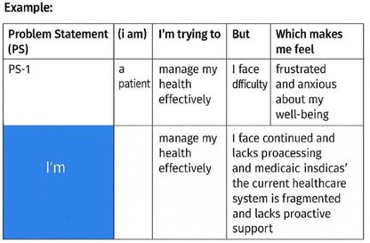

2.2 Empathy Map Canvas Date: 31 January 2025

Team ID: LTVIP2025TMID30263

Project Name: Health AI: Intelligent Healthcare Assistant Using IBM Granite Maximum Marks: 2 Marks

Empathy Map Canvas

An empathy map a simple, easy-to-digest visual that captures knowledge abou a user's behaviors and attitudes.

It is a useful to helping teams teans understand their users.

Creating an effective solution requires understanding their the person who is experiencing it, it. Exele participants consider how participants consider uset highs, lows, goals, and challenges

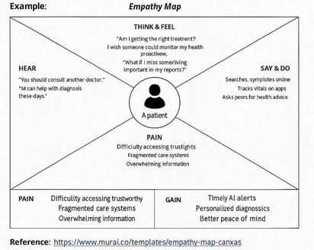

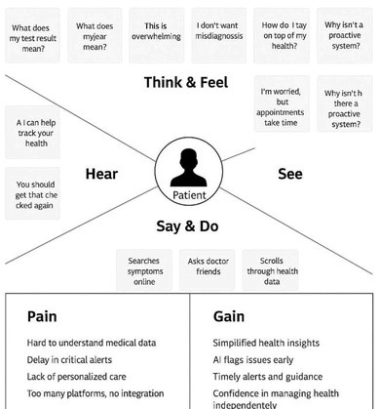

2.3 Brainstorming Date: 31 January 2025

Team ID: LTVIP2025TMID30263

Project Name: Health AI: Intelligent Healthcare Assistant Using IBM Granite

Maximum Marks: 4 Marks

Brainstorm & Idea Prioritization in Health AI

Brainstorming in Health AI promotes free, creative thinking to generate innovative solutions for healthcare challenges using artificial intelligence. To collect a wide range of ideas from diverse team members, then prioritize based on impact, feasibility, and urgency. Encourage maximum idea generation, regardless of practicality at first.

Cross-functional team members (AI developers, clinicians, analysts) co-create ideas. Ideal for distributed teams using tools like Miro or Mural.AI-driven symptom checking, disease prediction, treatment plans, and patient engagement tools. Impact – Patient outcomes and healthcare system improvement. Feasibility – Technical readiness with health regulations.

Reference: Brainstorm and idea prioritization template | Mural

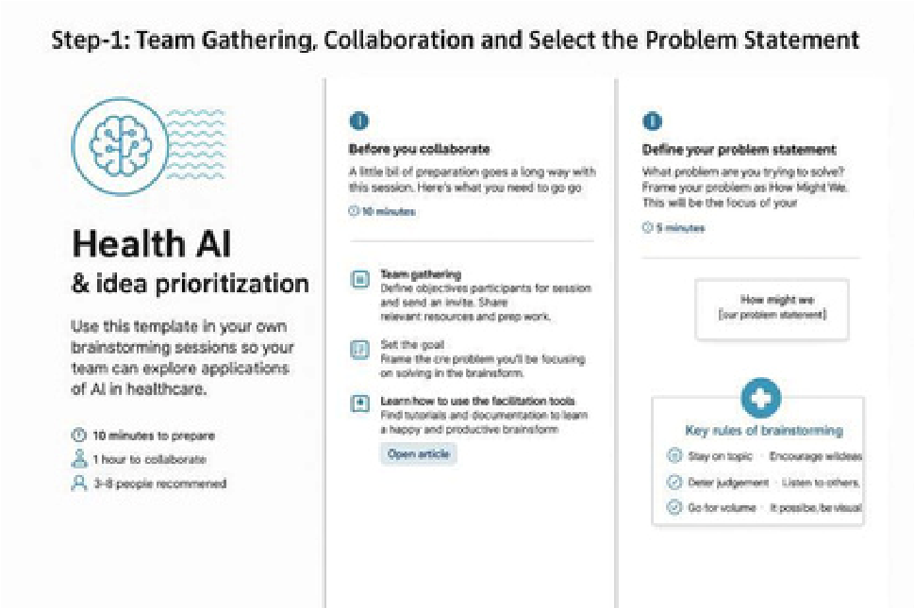

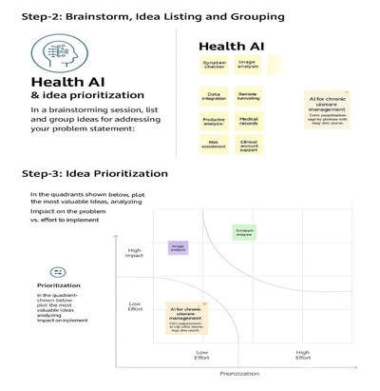

1. REQUIREMENT ANALYSIS
   1. Customer Journey Map

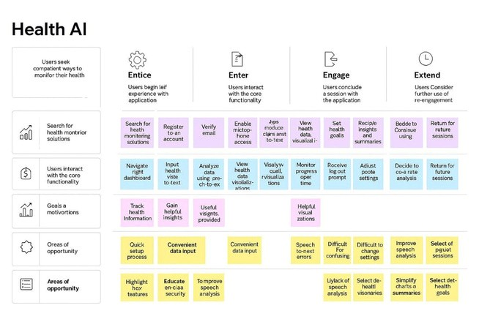

* 1. Solution Requirement

Solution Requirements (Functional & Non-functional)

📅 Date: 15 February 2025 🆔

Team ID: LTVIP2025TMID30263

📌 Project Name: HealthAI: Intelligent Healthcare Assistant Using IBM Granite

🧮 Maximum Marks: 4 Mar

Functional Requirements:

Following are the functional requirements of the proposed solution.

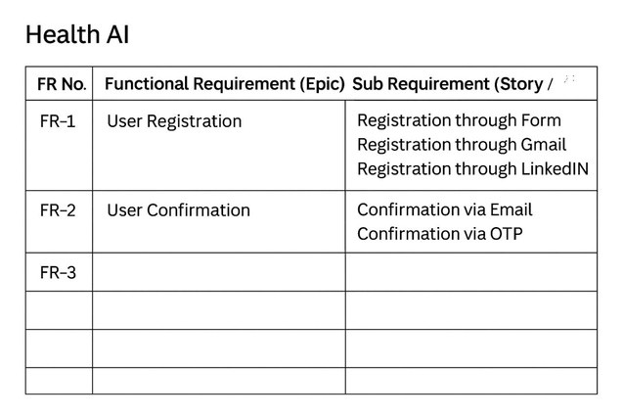

Non-functional Requirements:

Following are the non-functional requirements of the proposed solution.

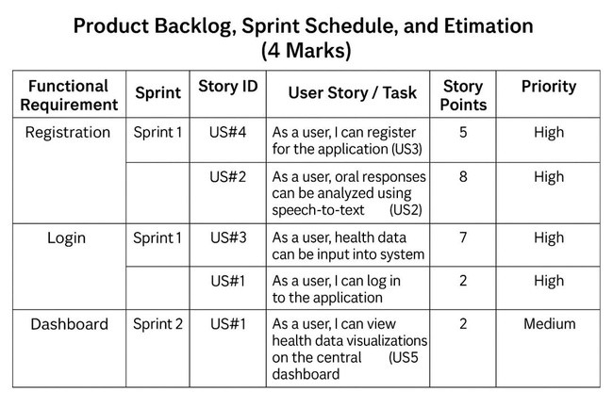

* 1. Data Flow Diagram

Data Flow Diagram & User Stories

📅 Date: 15 February 2025

🆔 Team ID: LTVIP2025TMID30263

📌 Project Name: HealthAI: Intelligent Healthcare Assistant Using IBM Granite

🧮 Maximum Marks: 2 Marks

Data Flow Diagrams: A Data Flow Diagram (DFD) is a traditional visual representation of the information flows within a system. A neat and clear DFD can depict the right amount of the system requirement graphically. It shows how data enters and leaves the system, what changes the information, and where data is stored.

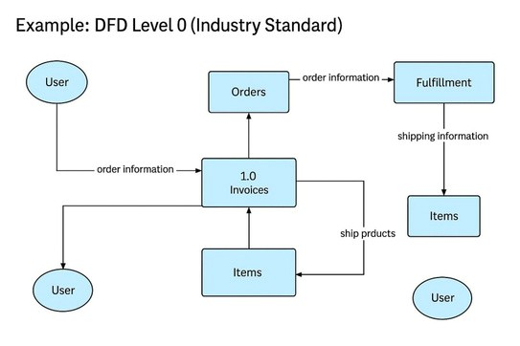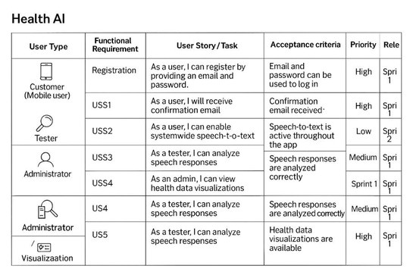

* 1. Technology Stack

Technology Stack (Architecture & Stack)

📅 Date: 31 February 2025

🆔 Team ID:LTVIP2025TMID30263

📌 Project Name: HealthAI: Intelligent Healthcare Assistant Using IBM Granite

🧮 Maximum Marks: 4 Marks

Technical Architecture – HealthAI

HealthAI’s technical architecture is designed to provide intelligent, personalized, and accessible healthcare assistance using IBM’s AI capabilities. The architecture bridges the gap between healthcare user needs and AI-driven digital solutions by clearly defining modules, workflows, and technology integrations.

It follows principles of modular design, AI integration, secure backend logic, and interactive frontend experiences.

References – Adapted for HealthAI

1. C4 Model – Software Architecture Visualization Used as the base modeling approach to definedifferent levels of HealthAI’s architecture (context, container, component). 🔗 https://c4model.com/
2. IBM Order Processing System (Pandemic Reference) Inspired HealthAI’s backend design by using modular components and AI-powered services similar to order-processing use cases. 🔗 https://developer.ibm.com/patterns/online-order-processing-system-during-pandemic/
3. IBM Cloud Architecture Center Provided best practices and patterns for integrating AI models and deploying cloud-based healthcare applications. 🔗 https://www.ibm.com/cloud/architecture
4. AWS Architecture Best Practices Used as a comparative reference to validate HealthAI’s scalability, resilience, and service-based integration approach. 🔗 https://aws.amazon.com/architecture
5. How to Draw Useful Technical Architecture Diagrams Guided the creation of simplified, functional diagrams for HealthAI's backend and AI data flow. 🔗 https://medium.com/the-internalstartup/how-to-draw-useful-technical-architecture-diagrams-2d20c9fda90d

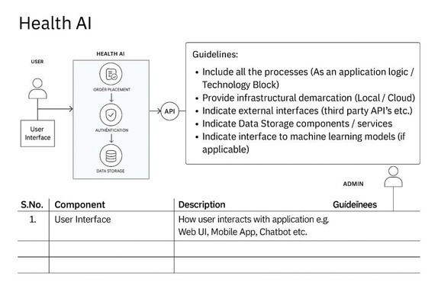

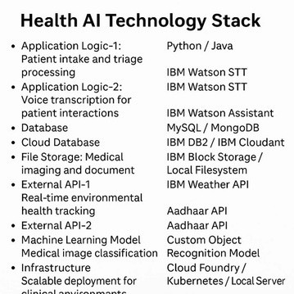

1. PROJECT DESIGN

4.1 Problem Solution Fit

Problem – Solution Fit Template :

📅 Date: 15 February 2025

🆔 Team ID: LTVIP2025TMID30263

📌 Project Name: HealthAI: Intelligent Healthcare Assistant Using IBM Granite

🧮 Maximum Marks: 2 Marks

Problem – Solution Fit Template : HealthAI solves a frequent and urgent problem: lack of easy access to valid healthcare information and insights. It taps into the existing behavior of users searching for medical information online and replaces it with a credible, AI-powered platform.

Purpose :

✅ Solve complex health-related problems using intelligent and accessible AI assistance

✅ Increase solution adoption by reflecting how users already seek medical information online

✅ Improve communication using conversational chat and visual analytics

✅ Build user trust with consistent, evidence-based responses

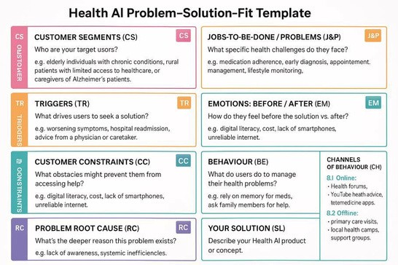



📅 Date: 15 February 2025

🆔 Team ID:LTVIP2025TMID30263

📌 Project Name: HealthAI: Intelligent Healthcare Assistant Using IBM Granite

🧮 Maximum Marks: 2 Marks

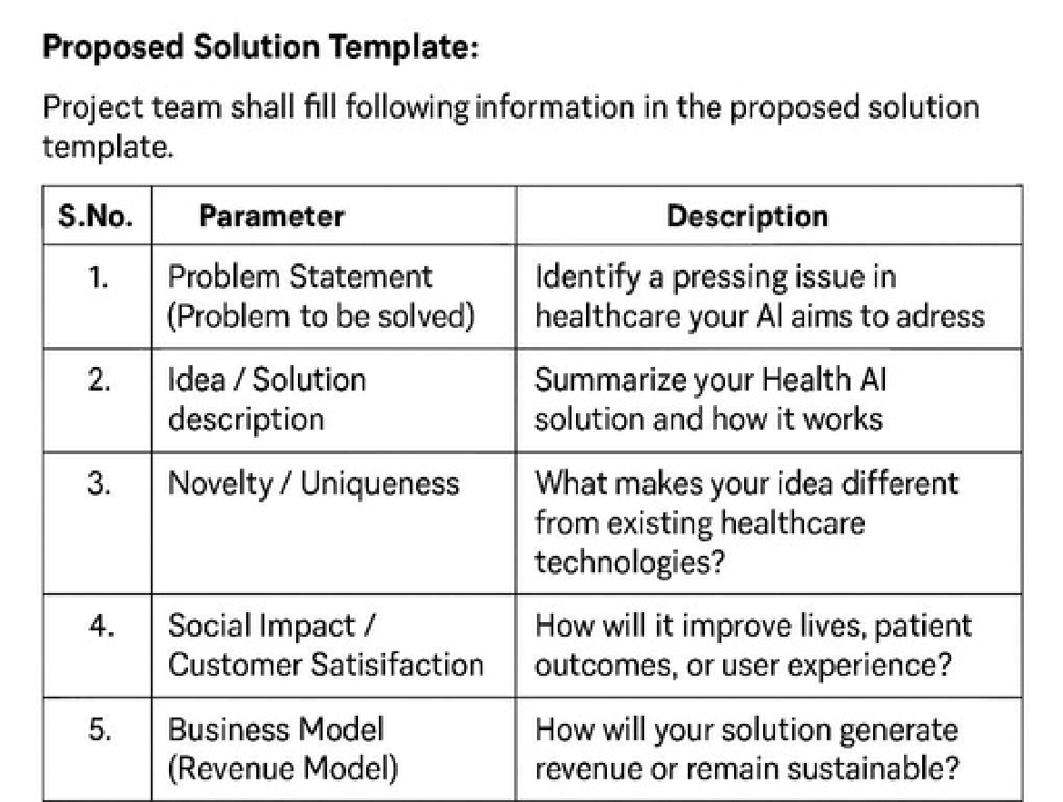

4.3 Solution Architectur

📅 Date: 15 February 2025

🆔 Team ID: LTVIP2025TMID30263

📌 Project Name: HealthAI: Intelligent Healthcare Assistant Using IBM Granite

🧮 Maximum Marks: 2 Mar

✅ Solution Architecture – HealthAI

Solution architecture in HealthAI serves as the bridge between real-world healthcare challenges and advanced AI-driven technology. It outlines how HealthAI is built to deliver accurate, personalized, and responsive medical support.

🎯 Goals of HealthAI’s Solution Architecture:

1. Identify the most effective AI-driven technology to solve the problem of inaccessible or unreliable healthcare information.
2. Design the complete structure — from user input (like symptoms or questions) to backend AI processing using IBM Granite and secure API handling.

3.Define key features and development phases, including modules like :

oPatient Chat oDisease Prediction oTreatment Plan Generation oHealth Analytics

🧮Key Characteristics of the HealthAI Architecture:

Modular and Scalable Design: Each core functionality is independently built using Python and Streamlit.

AI Integration: IBM Granite (13B Instruct v2) is used to process all medical queries and generate accurate, natural-language responses.

. User Interface: Streamlit provides an intuitive frontend with form-based inputs, chatbot interfaces, and dynamic visualizations using Plotly.

Data Flow: User inputs are sent to the AI model via a central shared function (shared_model.py), processed securely, and returned in structured output.

Security: Environment variables (.env) are used for API key management to protect sensitive credentials.

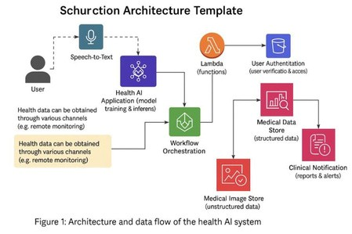

1. PROJECT PLANNING & SCHEDULING
   1. Project Planning

Project Planning Template (Product Backlog, Sprint Planning, Stories, Story points)

📅 Date: 15 February 2025

🆔 Team ID: LTVIP2025TMID30263

📌 Project Name: HealthAI: Intelligent Healthcare Assistant Using IBM Granite

🧮 Maximum Marks: 2 Mar

Imagine we have a 10-day sprint duration, and the velocity of the team is 20 (points per sprint).

Let’s calculate the team’s average velocity (AV

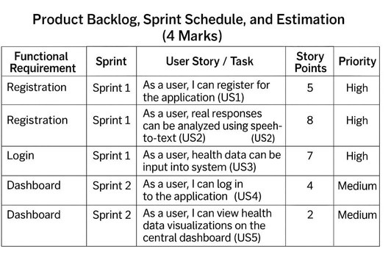

Velocity:

Imagine we have a 10-day sprint duration, and the velocity of the team is 20 (points per sprint). Let’s calculate the team’s average velocity (AV) per iteration unit (story points per day)

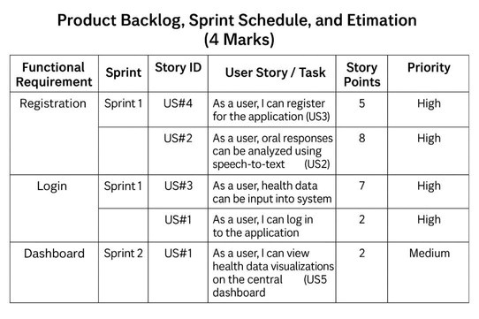

1. FUNCTIONAL AND PERFORMANCE TESTING
   1. Performance Testing

Functional & Performance Testing Template

Model Performance Test

📌Project Name: HealthAI: Intelligent Healthcare Assistant Using IBM Granite

📅 Date: 21 February 2025

🆔 Team ID: LTVIP2025TMID30263 🧮 Maximum Marks:

Test Scenarios & Result

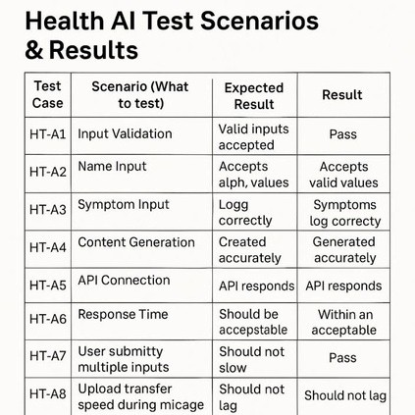

✅ 24/7 Accessibility: Users can access healthcare assistance anytime without waiting for a doctor.

✅ AI-Powered Responses: Quick and intelligent answers using IBM Granite enhance user experience.

✅ Early Disease Prediction: Helps in identifying potential health issues at an early stage.

✅ Modular System: Divided into four independent modules for better organization and usability.

✅ User-Friendly Interface: Built using Streamlit, it provides a simple and intuitive experience.

✅ Cost-Effective: Reduces the need for continuous human supervision in basic healthcare queries.

Disadvantages:

❌ Not a Replacement for Doctors: Cannot replace actual medical consultation or diagnosis.

❌ Depends on Internet Connection: Requires stable internet to function effectively.

❌ Limited to Pretrained Knowledge: IBM Granite model may not always be updated with the latest medical information.

❌ Security & Privacy: Requires strict handling of user data for ethical and legal compliance.

1. CONCLUSION

The HEALTHAI project demonstrates how generative AI, specifically IBM Granite, can be effectively integrated into healthcare applications. By providing intelligent responses to user queries, disease prediction, treatment suggestions, and health analytics, this system can assist users in managing their health proactively. Though it is not a substitute for professional medical advice, it acts as a supportive tool that can bridge the gap between users and healthcare information in real time.

1. FUTURE SCOPE

🔬 Integration with Real Medical Records: In future, the system can be connected to Electronic Health Records (EHR) for more personalized responses.

📱 Mobile App Development: A dedicated mobile version can improve accessibility on

smartphones.

🧮 More Advanced AI Models: Upgrading to future IBM Granite versions or fine-tuning with medical datasets for better accuracy.

🌐 Multi-Language Support: Expanding to regional languages can make it more inclusive.

🔒 Enhanced Security Measures: Implementing data encryption and secure login to protect user privacy.

Team ID : LTVIP2025TMID30263

Team Size : 5

Team Leader : Thathireddy Sankar Reddy

Team member : Nossam Pavan Kumar Reddy

Team member : Peddineni Rajkumar

Team member : Mangala Tharun

Team member : Kothaluru Vamsi Narendra